Name:

# Manjimup S.H.S Year 11 2015

# Mathematical Methods Investigation 1

In-Class validation

**HERON’S RULE**

*Score: ……… out of 34 = …………. %*

Total marks: 34 Time permitted: 45 minutes

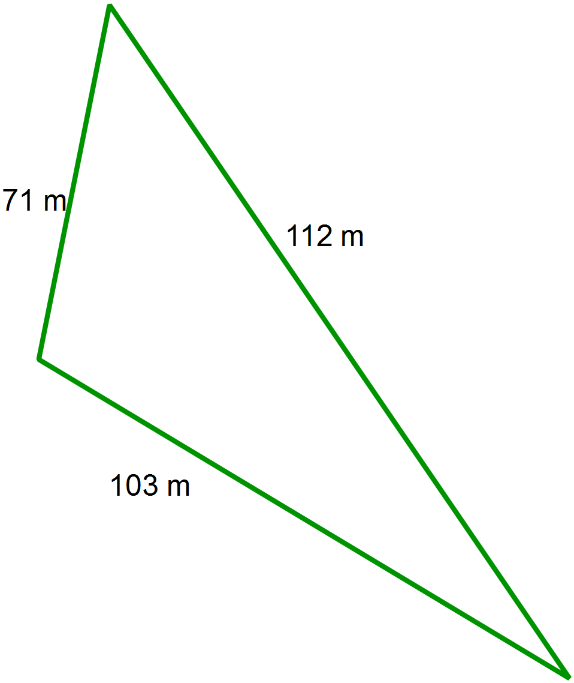

1. Use Heron’s formula to calculate the area,

to 2 decimal places, of this scalene triangle shown.

Show working.

[3 marks]

2. Use trigonometrical rules to find the area of this triangle

and to verify your solution to question 1.

Show clearly the mathematics you used.

[3 marks]

3. This equilateral triangle has the *same area* as the triangle from question one.

Determine the length of the side lengths, accurate to 2 decimal places.

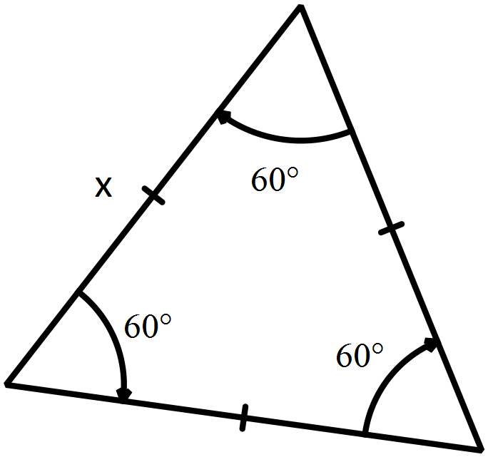

Show working.

[3 marks]

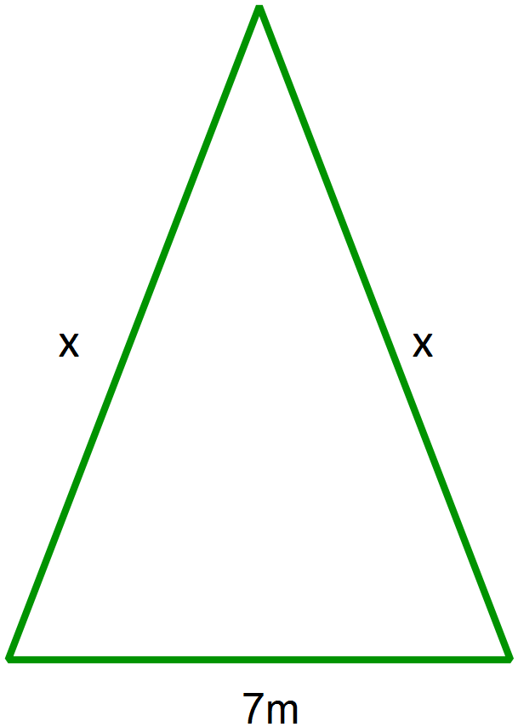

4. a) Show working to demonstrate that the

semi-perimeter, s, of this triangle

can be expressed as s = x + 3.5

.

b) Using Heron’s rule, write a simplified algebraic expression

for the area of this triangle, in terms of x.

c) Determine the value of x, when the area of the triangle is 25.18m2.

Indicate your method of solution.

[1,3,2 = 6 marks]

5. a) Use Heron’s rule to find the area of a triangle with sides 6cm, 7cm and 13 cm.

b) Explain why this solution occurs, using a diagram to assist you.

[1,2 = 3 marks]

6. a) Find the maximum area possible for a triangle with a perimeter of 90 cm.

Show clearly how you did this and use a sketch to illustrate your solution.

b) The rule for the maximum area of a triangle with a semi-perimeter of s is equal to .

Show working to verify this rule is correct for the triangle in question 6a.

[3,2 = 5marks]

7. Determine the dimensions of a triangle with an area of 1 hectare (10 000 m2) that has the smallest perimeter. Show how you did this.

[3 marks]

8. a) Given the following equilateral triangle, find an expression for s, in terms of a, the side length..

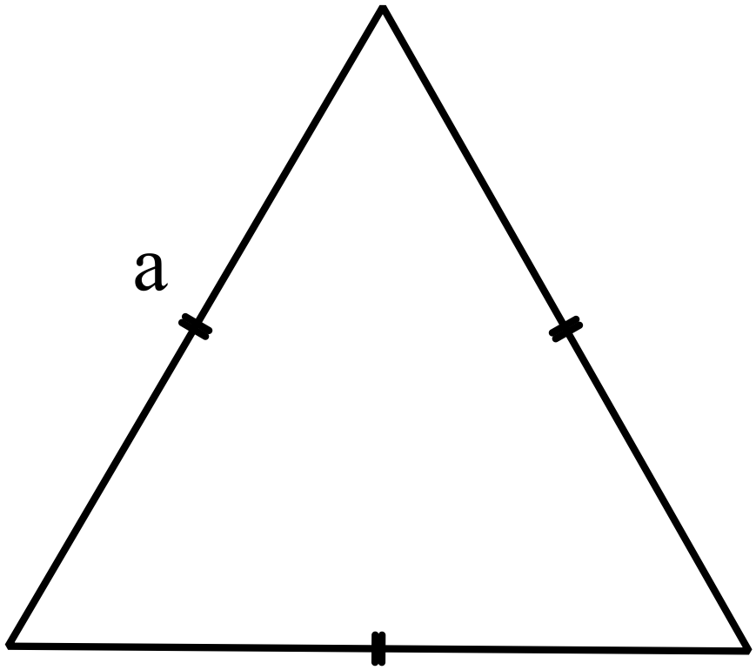

s =

b) Substitute this into Heron’s rule to find an unsimplified expression for area in terms of a.

A =

c) Show algebraic working to demonstrate that A is given by the expression .

You may use your Casio to assist with this if you wish but show each step.

d) Investigate what happens to the area of an equilateral triangle when the side lengths are doubled. Show working and conclusions below.

[1,2,3,2 = 8 marks]

THE END